Simple CTF

1. Deploy & Scan
- Deploy the Simple CTF machine in TryHackMe.
- Perform an initial scan using nmap:
nmap 10.48.163.35 -A

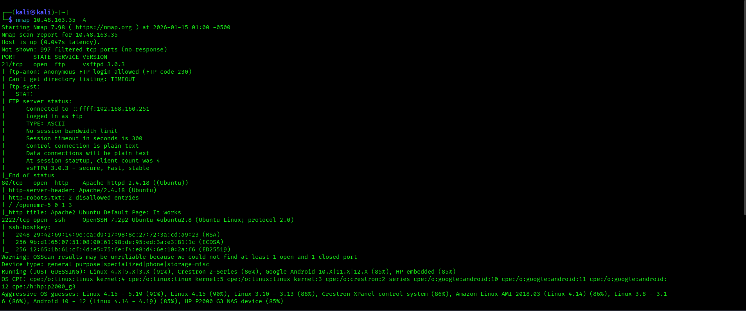

- Results:
  - Open ports: 21 (FTP), 80 (HTTP), 2222 (SSH)
  - Q1. How many services under port 1000?
➤ Answer: 2
  - Q2. What is running on the higher port?
➤ Answer: SSH

2. Web Enumeration
- Browse to http://10.48.163.35:80 — you’ll see the default Apache page.
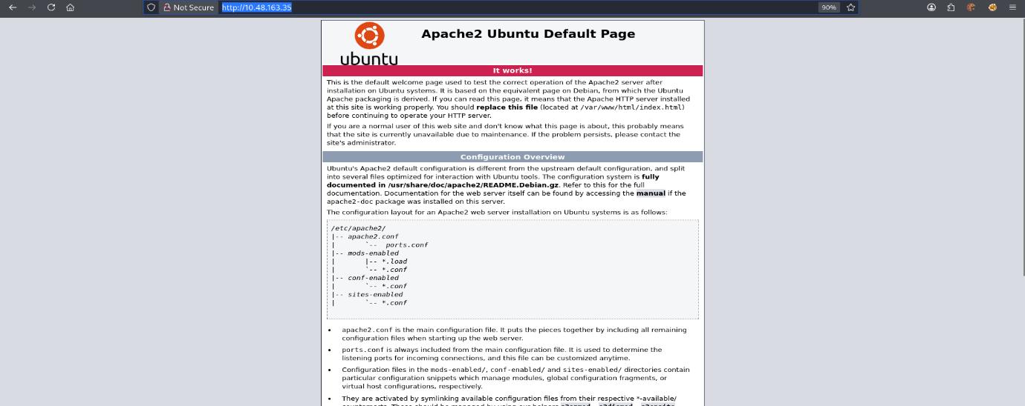

- Use a directory bruteforcer (e.g. dirb) to find hidden directories:

dirb http://10.48.168.35/
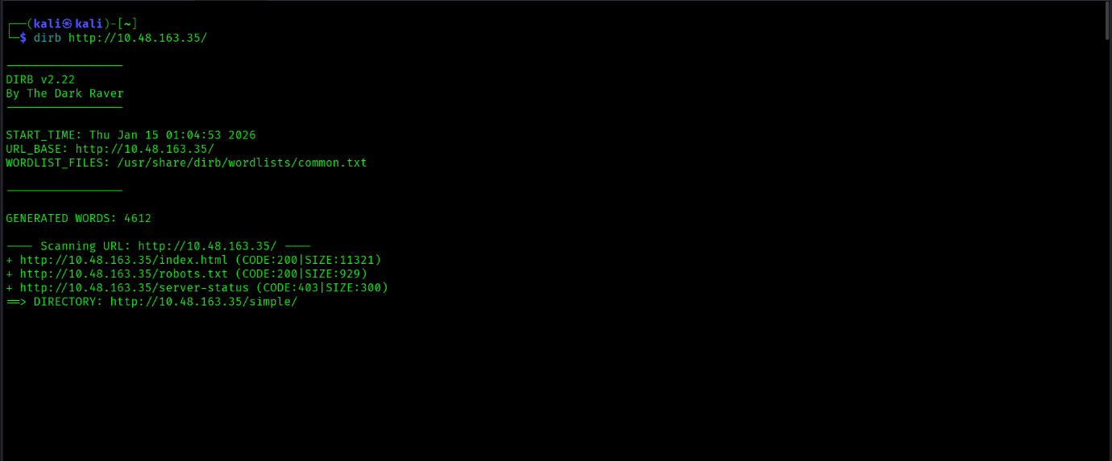

- You find /simple, a CMS site:
  - CMS Made Simple 2.2.8
  - Search online for known exploits.

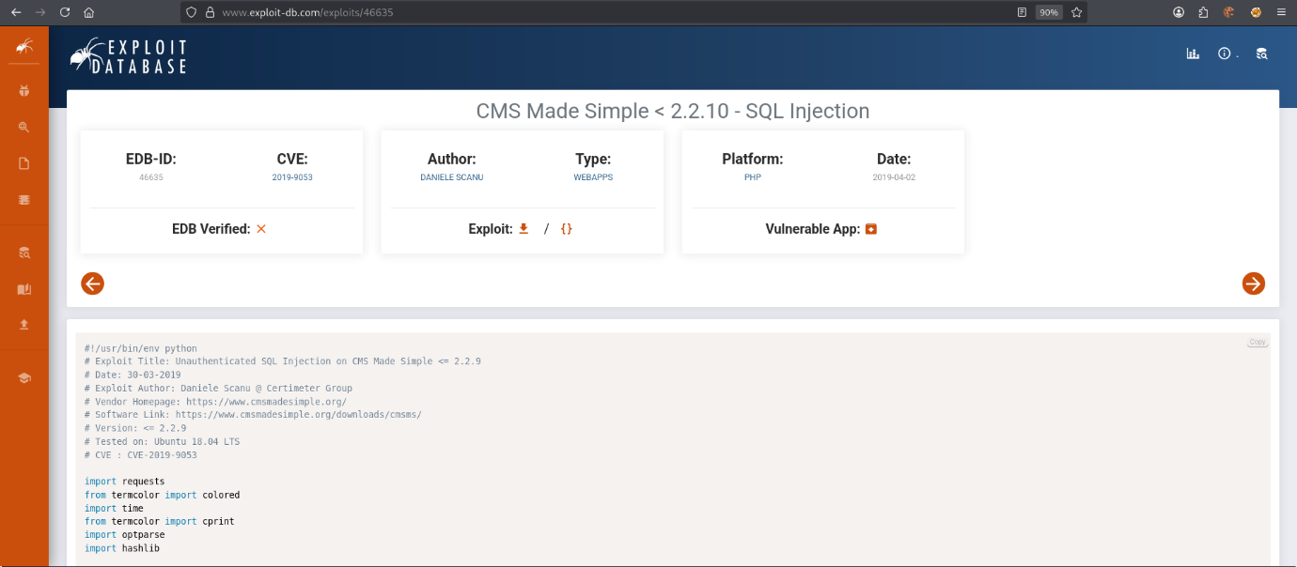

- Vulnerability found:
  - CVE-2019-9053
  - Type: SQL Injection (SQLi)
  - Q3. CVE used: CVE-2019-9053
  - Q4. Vulnerability type: SQLi

3.Exploitation
- Copy the script and paste it into a file with extentention .py
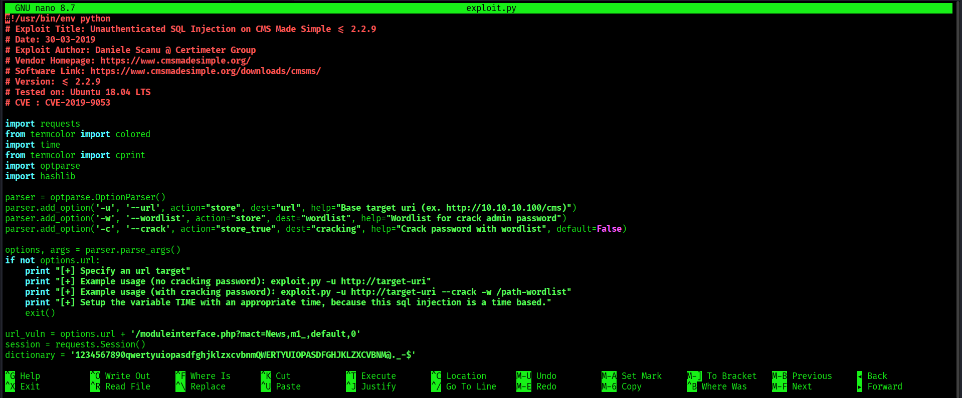

- Run the exploit with a wordlist to crack credentials:
python exploit.py -u http://<target-IP>/simple --crack -w /usr/share/wordlists/rockyou.txt
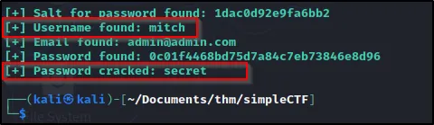

- Q5. What’s the password?
➤ Answer: secret
- Q6. Where can you login with those details?
➤ Answer: SSH

SSH & User Flag
- SSH in using the cracked credentials:
ssh mitch@10.48.165.35 -p 2222
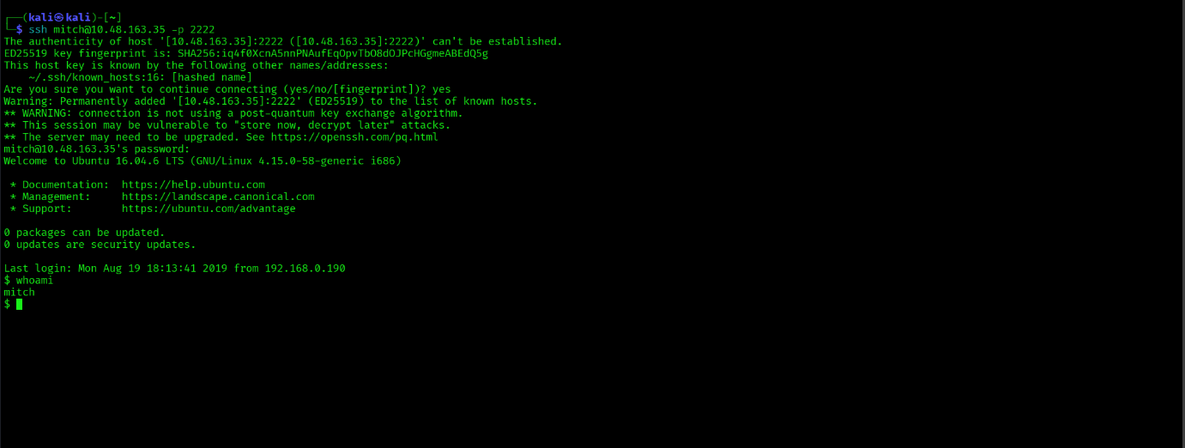

- After logging in:
  - View files and locate user.txt.
  - Q7. User flag: The contents of user.txt
- Check for other users:
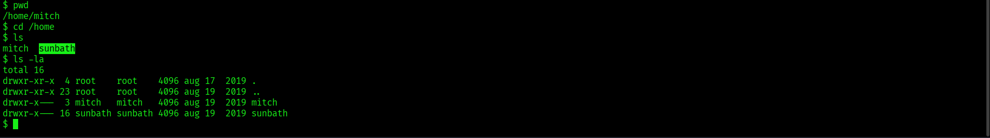

  - Found user sunbath
  - Q8. Other user name: sunbath

4. Privilege Escalation
- Check sudo privileges:
sudo -l

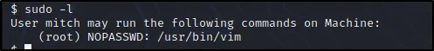

Mitch can run vim as root.

- Use GTFOBins technique to spawn a root shell:
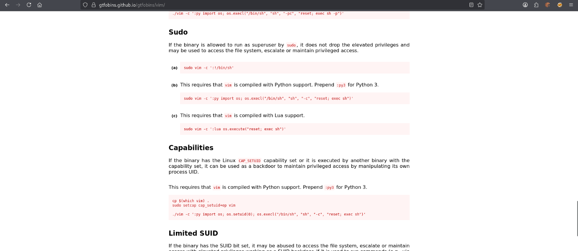

sudo vim -c ':!/bin/sh'
- You are now root!
  - Q9. What tool to spawn a privileged shell?
➤ Answer: vim
- Navigate to /root and read root.txt:

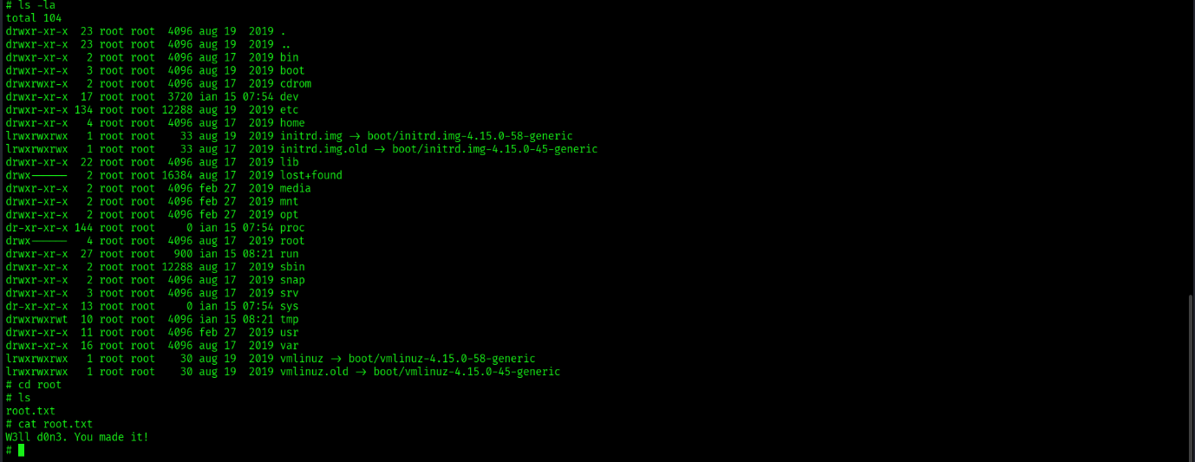
  - Q10. Root flag: The contents of root.txt
W3ll d0n3. You made it!

By
Anns Shanto

